**Assignment 2**

**The command line interface**

**Linux System Administration**

**Jesbin Jobi**

**200588911**

**ScreenShot1**

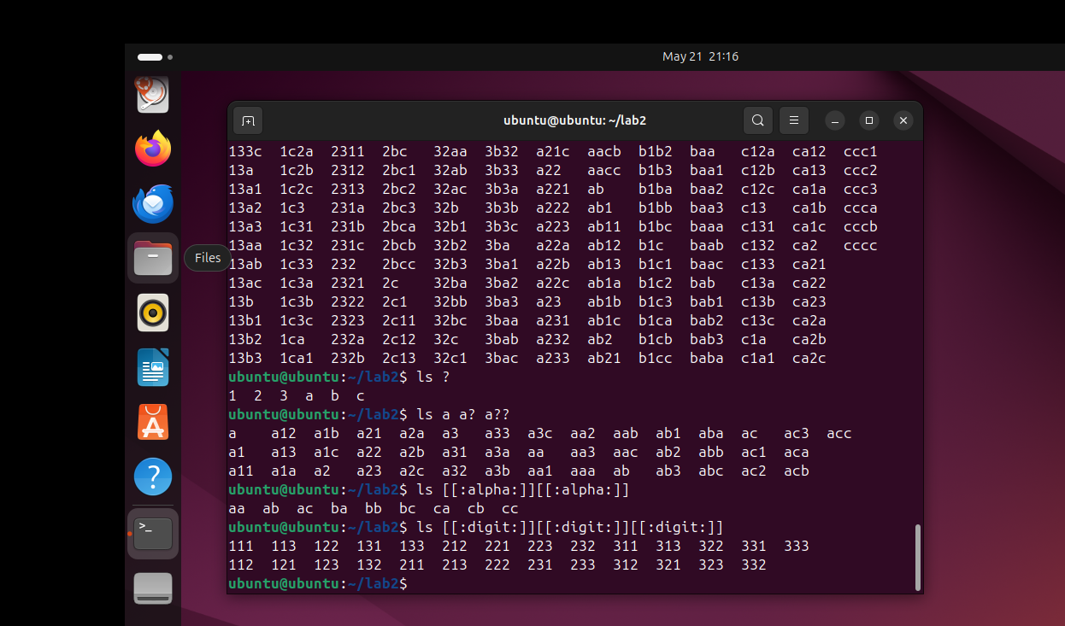

**Question 1: What is the command that accomplishes this?**

* mv a* b* c* dir_abc

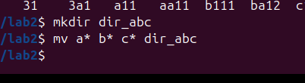

**Question 2: what is the command that accomplishes this?**

* cp [0-9]* numbers/

**Question 3: record the command that accomplishes this?**

* rm 12*

**Question 4: record the command that will remove the “numbers” directory and all its content**

* rm -r numbers

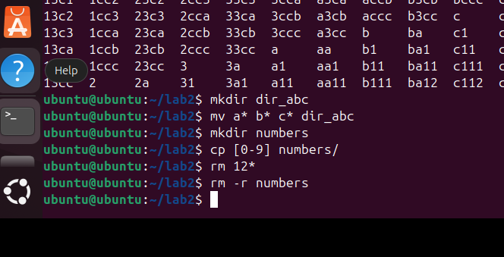

**Screenshot 2**

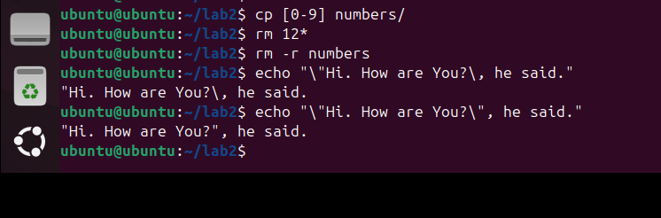

**Screenshot 3**